 |  | Dated: | 19-12-2022

PROJECT INFORMATION:

PROJECT ID |  | 03 |  |  |  |  |  |  |  | NUMBER OF MEMBERS |  | 32
TITLE | 10th Order FIR System
SUPERVISOR NAME |  |  | Dr. Wasiq Ali |  |  |  |  | SUPERVISOR TYPE |  |  | INTERNAL/EXTERNAL
SUPERVISOR EMAIL |  |  | wasiq.ali@cuiatk.edu.pk |  |  | SUPERVISOR PHONE |  |  | +92 314 5041063

PROJECT MEMBERS:
MEMBER NAME | REG. NO. | SIGNATURE
Muhammad Kaleem Ullah | FA19-BCE-007/ATKFa1
Muhammad Ubaid | FA19-BCE-008/ATKFa1

CHECKLIST:
Number of additional pages attached with this form
I/We have attached the finalized Project Objectives  using the form F3A | YES / NO
I/We have attached the finalized Project Timeline  using the form F3B | YES / NO
My/Our supervisor has attested the attached pages | YES / NO
I/We have agreed to initiate this project from today | YES / NO

 |  | Dated: | 19-12-2022

Submit this document as an attachment to the form F3

PROJECT ID |  |  | 03 |  |  |  |  |  |  | TOTAL NUMBER OF OBJECTIVES |  |  |  |  | 703
TITLE |  | 10th Order FIR System
No. | DESCRIPTION OF OBJECTIVE |  |  |  |  |  |  |  |  |  |  |  |  | PRIORITY*
1 | Understanding of the filters |  |  |  |  |  |  |  |  |  |  |  |  | A
2 | Difference between FIR and IIR |  |  |  |  |  |  |  |  |  |  |  |  | A
3 | Implementation of FIR system in Verilog HDL |  |  |  |  |  |  |  |  |  |  |  |  | A
*PRIORITY LEVELS |  |  |  |  | A | Must achieve | B |  | Recommended |  | C | Optional
Explain project objective with the help of block diagram and with flow chart (if possible). Add additional pages if required.

Let us consider an FIR filter of length M (order N=M-1, order = length – number of delays)
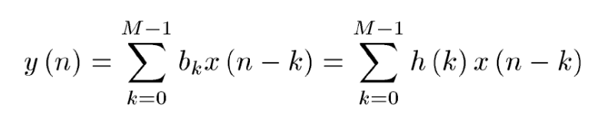
where h(k), k=0,1,…,N-1, are the impulse response coefficients of the filter.
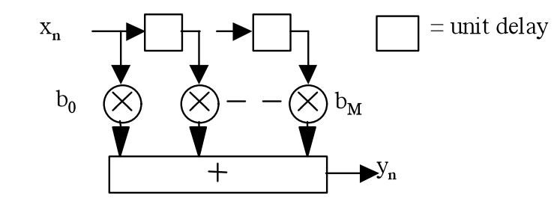
The basic FIR filter is characterized by the following two equations:
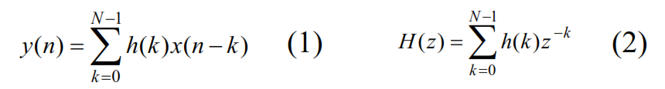
where h(k), k=0,1,…,N-1, are the impulse response coefficients of the filter, H(z) is the transfer function
and N the length of the filter

According to this these two equations, as we have to design 10th order finite impluse response (FIR) so we will be using N equal to 11 so our order of the FIR filter will be 10th.
We will be creating diagram of the equation according to our choosen quesiton of 10th order.

Applications:
Finite impulse response (FIR) filters are widely used in communication, consumer electronics, audio, and other signal processing applications. One of the important applications of FIR filters is as a Hilbert transformer. Hilbert transforms are very useful especially in detecting the instantaneous frequency and envelop amplitude of the signal. For synthesis of a Hilbert transformer, FIR filters are preferred because they can have exact linear phase, their stability is guaranteed, and they are less sensitive to the rounding of coefficients.

 |  | Dated: | 19-12-2022
Submit this document as an attachment to the form F3

PROJECT ID |  | 03 |  |  |  | TOTAL NUMBER OF OBJECTIVES
TITLE | 10th Order FIR System
No. |  |  | STARTING WEEK DATE | DESCRIPTION OF MILESTONE |  |  | DURATION  IN WEEK
1 |  |  | 2-12-2022 | Proposal Documentation |  |  | 2.5 Weeks
2 |  |  | 19-12-2022 | Mathematical Work |  |  | 1 Week
3 |  |  | 26-12-2022 | Verilog HDL Implementation |  |  | 1 Week
4 |  |  | 3- 01- 2023 | Project Report |  |  | 1 Week
5 |  |  | 10-01-2023 | Presentation |  |  | 1 Week

Supervisor’s Signature

